CEN 4010 Principles of Software Engineering, Summer 2020

Milestone 5: Final Project Delivery and Demonstration Group 6 – Covid Communicator

Team number: 6

Team members:

Product Owner: Grant Lundberg: [glundberg2017@fau.edu](mailto:glundberg2017@fau.edu)

Scrum Master: Christian Bastien: [cbastien2018@fau.edu](mailto:cbastien2018@fau.edu)

Development Team: John Callaghan: [jcallaghan2019@fau.edu](mailto:jcallaghan2019@fau.edu)

Development Team: Rishi Patel: [rishipatel2018@fau.edu](mailto:rishipatel2018@fau.edu)

Documentation Date: 8/5/20

History Table:

|  |  |
| --- | --- |
| Date of Revision | Description |
| 7/28/20 | Changing the original requirement in Milestone 1 which required the app to be accessible on web browsers. |
| 7/28/20 | The user will log in with a username rather than entering their email address. |

## **Product Summary**

The world today has changed a great deal in the past few months. With the rise of Covid-19 forcing people into lockdown, feelings of isolation and loneliness are inevitable. Now more than ever, it is difficult to feel connected to other people. This is why we developed the “Covid Communicator.” Covid Communicator is a desktop app which will allow those who feel lonely the chance to chat with others who feel the same. The user will be connected to another in a chatroom and given the opportunity to chat about whatever they like. Our app values friendliness and will attempt to brighten the day of anyone who uses it. Covid Communicator will be a mental health benefit to those who feel lonely during the epidemic.

Product Name: Covid Communicator

Major Committed Functions:

1. Your username and password are only requirements to log in.

2. The password will be encrypted in the server.

3. The user will be able to send a message and see it in the chatroom.

4. The chat will be completely anonymous.

# **Milestone documents**

**Executive Summary**

The world today seems like a dark place. With the rise of Covid-19 forcing people into lockdown, feelings of isolation and loneliness are inevitable. Now more than ever, it is difficult to feel connected to other people. Depriving people of this connection is dangerous to their mental health. While it is still unsafe in many places to interact with people, there are still ways to allow people to feel that connection they are missing. This is why we will develop the “Covid Communicator.” The Covid Communicator is a desktop app which will allow those who feel lonely the chance to chat with others who feel the same. Our app values friendliness and will attempt to brighten the day of anyone who uses it. Covid Communicator will be a mental health benefit to those who feel loneliness during the epidemic.

**Competitive analysis**

|  |  |  |  |  |  |
| --- | --- | --- | --- | --- | --- |
| Features | Chatting between users | Likes and reactions | Focus on mental well-being | News feed | Allows advertisements on app |
| Covid Communicator | yes | no | yes | no | no |
| Twitter | yes | yes | no | yes | yes |
| Facebook | yes | yes | no | yes | yes |

While there are already applications which are designed to help a user connect with others, those connections are not always positive. Also, these applications are used as news sources and a place for advertisements, which can reduce the overall mental health benefit. Our product will be designed to capitalize on the features which competitors such as Facebook and Twitter are lacking in. Mainly, our application will be a service to our user’s mental health and will be designed to be an enjoyable break from the harshness of the world today. Given the overall draw of the app is connection while isolating, we expect the interactions will be more pleasant than those on social media sites.

**Data definition**

Covid-19: a mild to severe respiratory illness that is caused by a coronavirus.

Covid Communicator: A desktop app which our team will be developing.

Python: a high-level general-purpose programming language.

App: an application which allows you to perform specific tasks or offers a service.

GitHub: web-based version-control and collaboration platform for software developers.

Visual Studio Code: Source-code editor made by Microsoft.

Qt: Used for developing graphical user interfaces (GUIs) and multi-platform applications that run on all major desktop platforms and most mobile or embedded platforms.

LAMP: is a web development stack that has Linux, Apache, MySQL and PHP components

UML: Stands for Unified Modeling Language. Provides a standard way to visualize the system.

**Overview, scenarios and use cases**

The average user of this service will be a very social person who longs for the social interaction which Covid-19 has diminished. They will be someone who wants to create small talk or have a casual conversation with other people in lockdown. Given that the pandemic has forced many people to only interact with close family and friends, this is an opportunity to communicate with someone other than those who you are quarantined with. This user could be inexperienced with apps or software, which means our app must be simple to use. They should also be able to access the app and begin using it without any tutorials or prior knowledge. The app will allow the user to communicate with other people easily. Given the types of users which will gravitate toward this service, the interactions should be very pleasant and more casual than interactions on other sites.

Scenario: Mike is a hair stylist at a local barbershop. He has worked at the same barbershop shop for 15 years and has many clients which he has become close with. He looks forward to seeing and talking with them about their lives. However, due to Covid-19, the barbershop had to close indefinitely, and he is now isolated at home. Through the weeks of quarantine, he grows lonely. He misses the casual conversations he once had daily with his clients. He learns about a new app called “Covid Communicator” which can bring back the casual human interaction he misses. After using the app, he realizes the conversations he had on Covid Communicator are very similar to the ones he had as a barber and begins to feel less lonely.

**High-Level Functional Requirements**

1. There should be no risk of user’s information being leaked without their consent.

1.1. The system should allow the user to communicate to another user anonymously.

2. The user should be able to understand the app with no tutorial or time spent learning.

3. The system should display bright imagery with happy connotations.

* Due to time constraints, we were not able to focus on the aesthetics of the app. This is something we would like to do in the future.

**Non-Functional Requirements**

1. Users shall log in with a password.

1.1 Users will also log in with their email address.

1.1 Passwords must be encrypted in server.

2. The system should be able to support at least 100 users.

**High-level system architecture and database organization**

The language we will be using for development of the Covid Communicator is python. We will be doing our coding with visual studio code. For the graphical user interface of the app, we will be using Qt. Finally, our desktop application will be communicating with a database on the lamp server.

Database Organization: In the database, we have our major segments. first off, the registration part where our primary key will be the ID, each user will have their own unique ID assigned to them this will help us store and keep track of every user. The rest of the parameters will be rendered into our database with the assigned ID. from this the user can start chatting. With the chat box our ID specified will be corresponding to the chat field ID. This will allow simply storing of messages with every unique ID. The purpose for this database is to have an ID assigned to each individual who creates an account, that same ID will be used in the chat room to see who is chatting with who.

High-Level UML diagrams

Figure - Class Diagrams

Figure - Sequence Diagrams

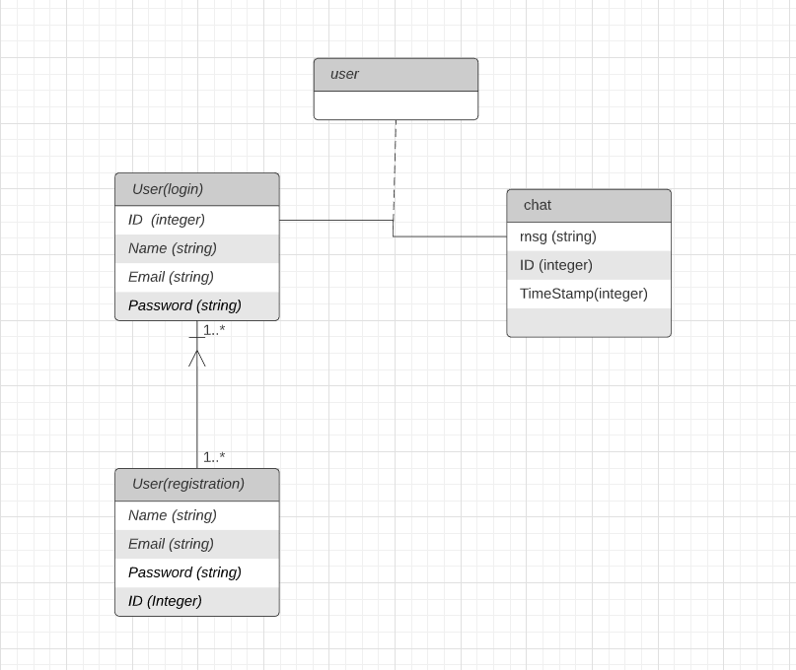

Figure - Database Schema

**Identify actual key risks for your project at this time**

* Skill: Our group is overall less experienced than the average software engineering team. To combat this, we are working together, and each person is focusing on the parts which they excel at. Also, we are watching tutorials and doing research into topics which we are unfamiliar with.
* Time: This product has multiple deadlines to meet, and it is important to not miss a deadline. To make sure we are on time with our product, we are paying close attention to those deadlines. We are also using our Trello space to make sure every is on the same page about what is due and when.

**Feedback Summary**

The feedback we received centered around creating adding more detail to our scenarios and to our requirements. We also needed to add prioritization to our non-functional requirements.

## **Screenshots of actual final product as shown in the demo**

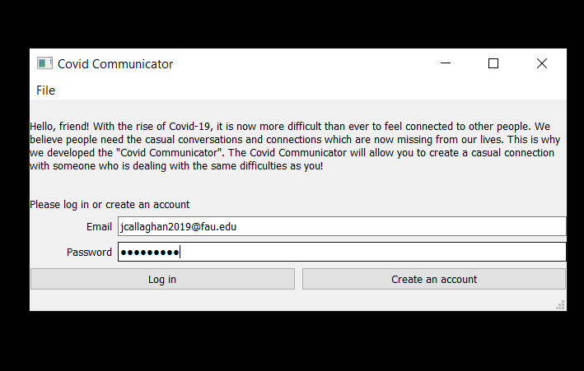

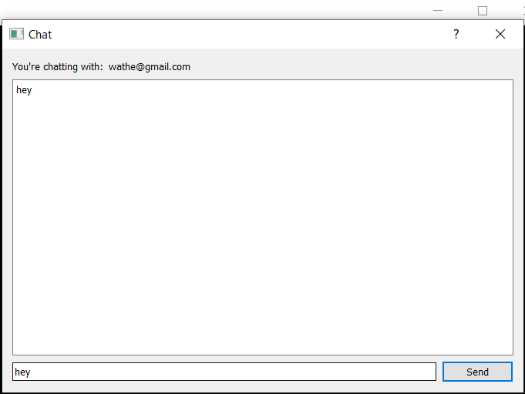

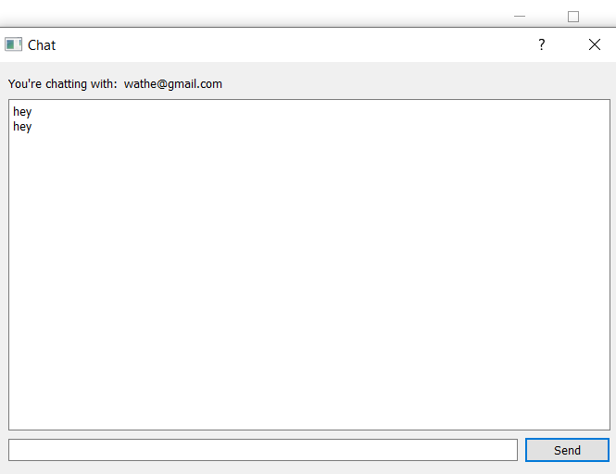

## **Google analytics plot for your website**

Since our product is an app and not hosted on a website, we do not have a google analytics plot.

## **Team members contribution**

|  |  |
| --- | --- |
| **Member** | **Participation** |
| John Callaghan | 25% |
| Grant Lundberg | 25% |
| Christian Bastien | 25% |
| Rishi Patel | 25% |

GitHub Repository:

<https://github.com/glundberg2017/cen4010-s2020-g06>

Scrum practice management Trello:

<https://trello.com/cen4010s2020g06>

Final product presentation: https://youtu.be/dIx0_WjhXZQ

**Individual Contribution**

John Callaghan:

* Organized and submitted milestones 1-5.
* Created the GUI Balsamiq mockups for milestone 2.
* Created the video demonstrations and presentation of the product.
* Oversaw Trello workspace.

GitHub Commits: 11

Grant Lundberg:

* Create the client app.
* Created the sequence & class diagrams.
* Oversaw python coding.

GitHub Commits: 18

Christian Bastien:

* PHP database API.
* Created all PHP pages (login.php , get users.php , send_message.php, get_messages.php)

GitHub Commits: 2

Rishi Patel:

* Led the database design.
* Created database outline
* Created high-level UML diagrams.

GitHub Commits: 6

## **Post-project analysis**

Going into this class, our group wasn’t sure what to expect. None of us had ever gone through the software engineering process to create a product. The first thing we learned very quickly was just how much documentation and planning goes into creating a product. Deciding how to plan for our product was our first challenge. However, we communicated as a group and got through the first three milestones without issue. It was during milestone 4 we had our first serious problem. While creating the beta version of our chat app, we realized we didn’t have direct access to our database, which meant we couldn’t establish a connection between the database and our app. This prevented us from saving any info, such as passwords and messages, from our app. This was an unforeseen issue which was realized too late to fix before milestone 4’s due date. Though the issue was eventually resolved, we were unable to have a true beta version of our app to test. This put our product behind schedule, which we had to work to overcome. Our team views this setback as a lesson in how problems can occur at any point in the software engineering process. Next time, our team would like to be better at time-management so we could leave extra time for unforeseen issues. Additionally, our team would like to pay better attention to all the milestone requirements, so we know exactly what is needed and when. While we finished the basic functionalities of the chat app, there are a few upgrades we wish to add. In the future, we would like to improve the app graphically. There are various improvements we could add, such as including more color and having icons for each person’s messages. This would be one of the first additions we would make to our app. To conclude, our team is happy with how our engineering process went and we feel like we learned a great deal in the course.